Data Analyst Trial Assessment
Isabel Melendez

For: Marketing and Sales teams at Smiley Real Estate

Goal: Summarize sales performance at a large-scale view for most of 2025

Best Markets

I used the original variables in the markets sheet to create new variables for comparing the 50 markets.
These new variables are:
- Ratio of listings per 100K residents: This is representative of the available housing supply relative to the market’s population. The calculation used to create this variable is:
(listings_on_market_count / population) *100000
- Difference in Media Price Closed to Listed: This tells us if the median prices of homes closed in this area is higher or lower than the initial listing price. The calculation used to create this variable is:
price_closed_median - price_new_list_median
- Percentage of Listings with Price Decrease in 30 days: This is an indicator of how prices are decreasing in the market recently. The calculation used to create this variable is
(listings_price_decrease_count / listings_on_market_count) *100
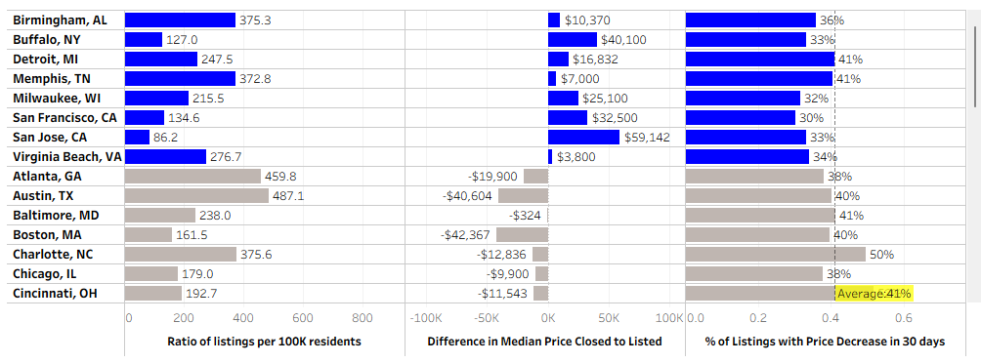
I used categorization to color the markers based on whether it was a strong seller’s market. The criteria for this labeling is based on:
- If Difference in Media Price Closed to Listed is positive.
- Percentage of Listings with Price Decrease in 30 days is equal to or below the average of 41%.
Using this, I narrowed the markets down to 8. Since the average Percentage of Listings with Price Decrease in 30 days decreased for this subset, I chose to narrow it further by only selecting the markets that had a below 35%.
In no order, the following 5 markets are the best markets in terms of higher closing prices of homes and low velocity of price decreasing in the last 30 days:
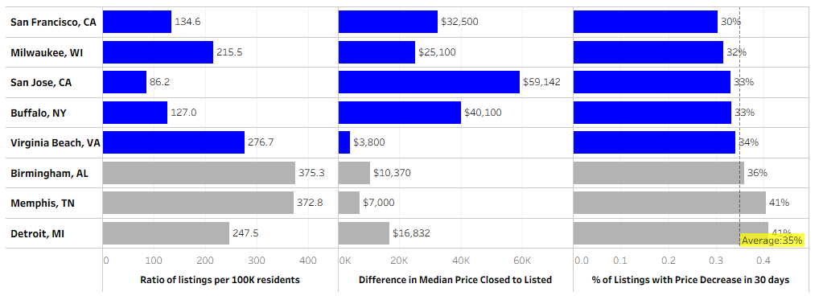

I noticed that the markets with the highest supply of homes per 100,000 residents tended to have closing prices much lower than the listing prices. Examples include Miami, FL and Tampa, FL.

Best Agents

The top agents for each market are shown in the Best Agent by Market.csv file. I decided on these agents based on the average percent of closed deals, from both buyer customers and seller customers, and their average rating. If the top agent with the highest average rate of closed deals had a lower average customer rating than the next best agent, I identified the next best agent as best overall in that market.

These are the top agents overall are shown below. They are ordered by decreasing average percent of closed deals from both buyer customers and seller customers. Customer satisfaction was used to filter agents further. Only agents with at least 4 customer reviews and an average rating of 2.95 or above were included in this ranking.
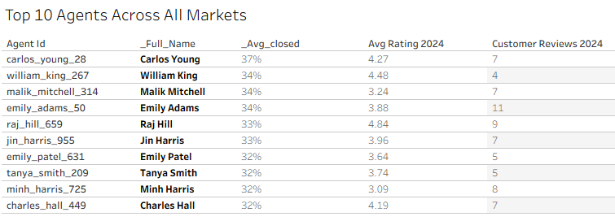

One area for growth

Using the amount and sale_id variables in the sales sheet, I created a new variable for the average price per sale. The formula for this variable was:
SUM([Amount]) / COUNT([Sale Id])
The average price of a single sale was highest in Q4 2025, shown below. However, the number of sales calls was lowest in Q4 2025. My suggestion for the upcoming year is to double down on sales calls and marketing efforts heading towards the end of the year.
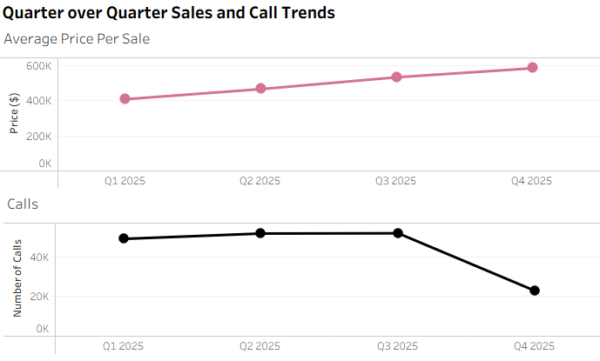

What if you had more time and data sources?
If I had more time, I would have liked to explore the number of calls by markets to see if there was a wide variety there or not. I would have liked to compare that to what I found in the first section of the analysis on the best overall markets.
In the customers sheet, we have only some detail, such as markets, but if we had available more demographic data I think that would be interesting to explore.

The process
I viewed this from a comparative lens, so much of my analysis was built on calculated fields that could be used to properly compare markets, agents, etc. I relied on proportions, percentages, and averages to do this. Some of the original fields were valuable as is, such as the customer_id for blending sheets, however many I viewed as necessary building blocks for comparative analysis. I used Tableau to analyze, visualize, and create calculations from the data. I spot checked some calculations using the original Google Sheets data set. I also used Google Gemini to assist me to debug the calculations. Since I had to blend different sheets for analysis, there were challenges I faced with properly visualizing the data. Multiple times I faced issues with the visualizations displaying properly, or at all.

